# Customer Registration

Customer Info: All below information is correct, we need not to update this screen.

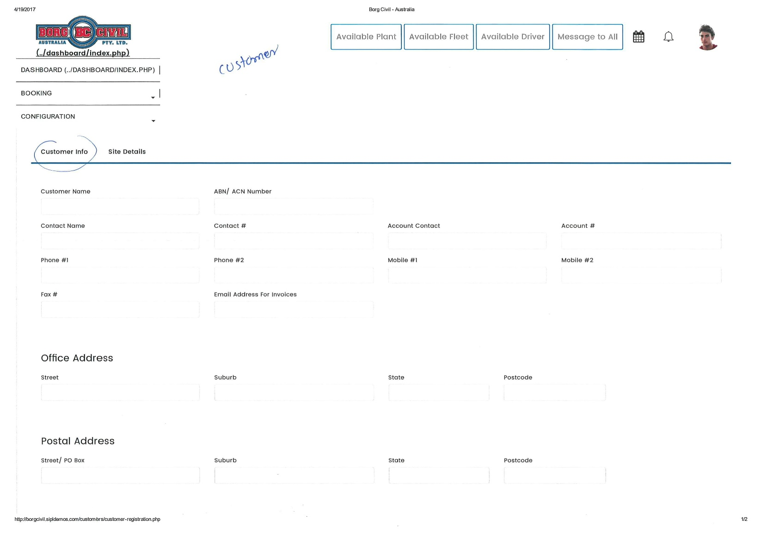

Site Details:

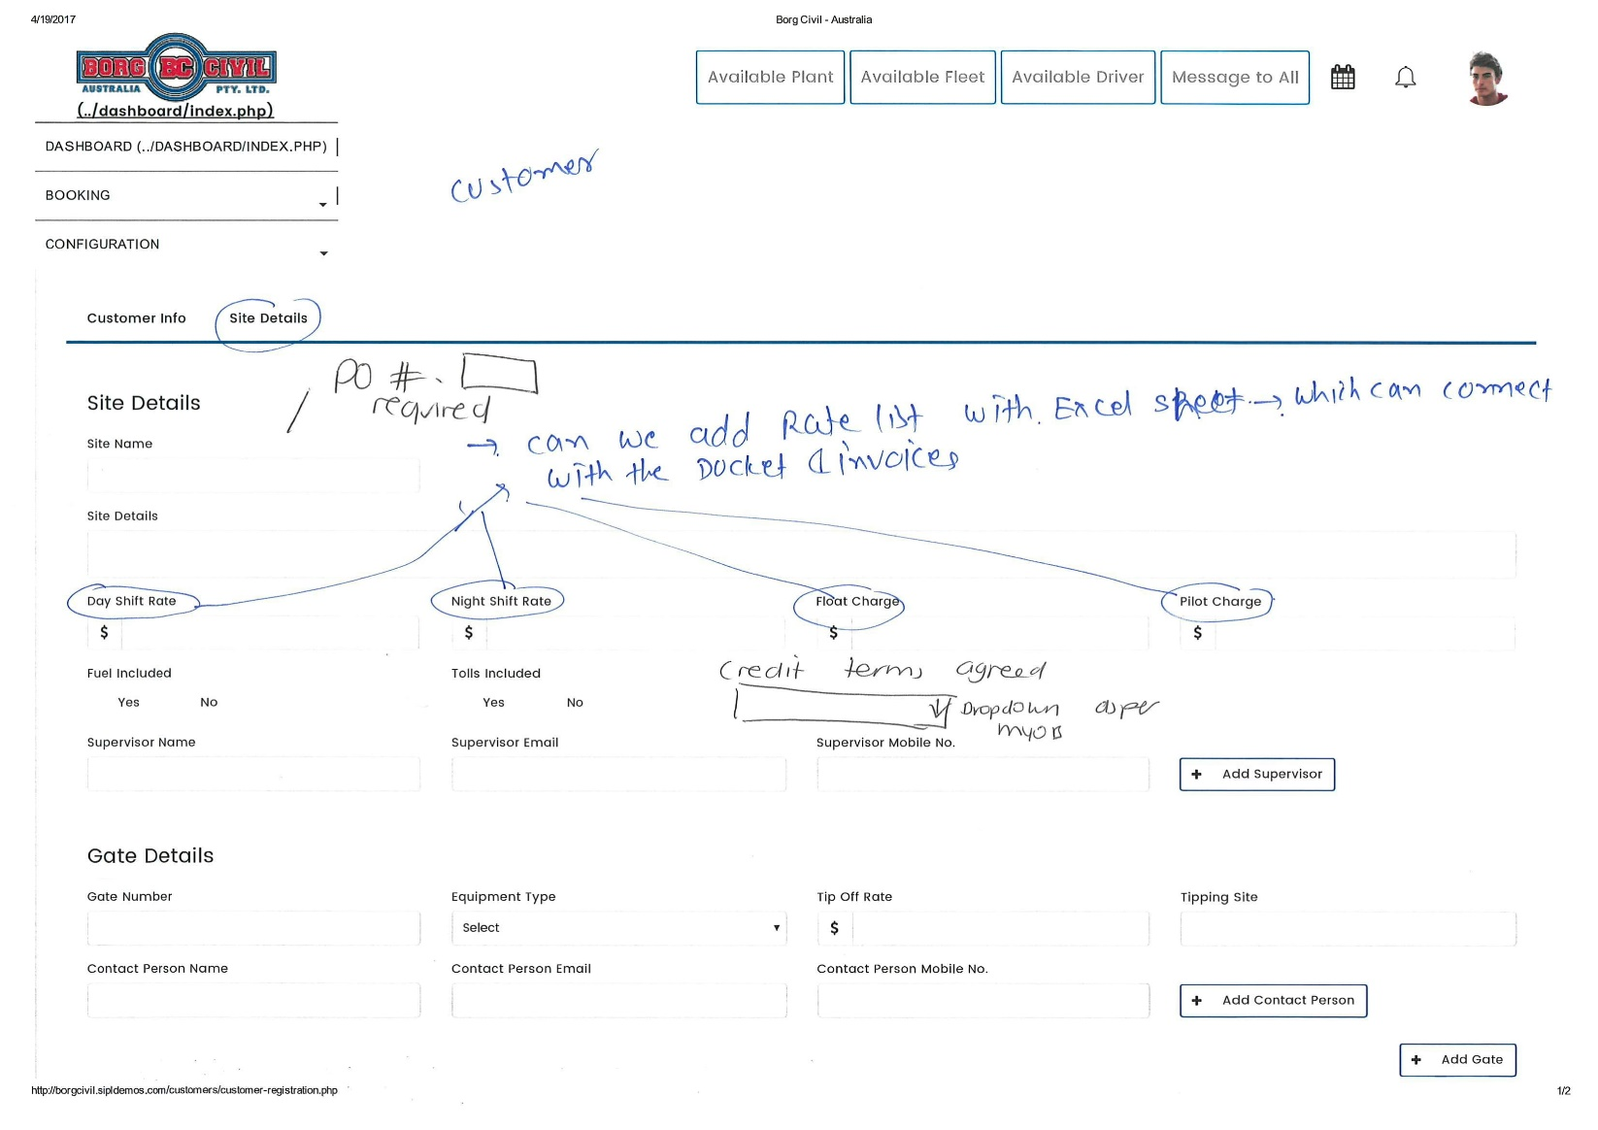

SIPL Understanding:

* We need to add P.O. (Purchase Order) number in site details.
* There will be dropdown for “Credit Terms Agreed”, it will have number of days 1,2,3,4,5 and so on. It should be 30 ,60 ,90 and End of Month 30/60/90 Days
* Admin can select number of days for credit terms from above dropdown.

***Note:*** *For now, we will not be able to fetch data from MYOB into our Fleet Management application.*

SIPL Queries:

* Is P.O. number will be purchase order number? Yes
* What will be the use of purchase order and its impact in the application or booking? -It is requiring for jobs as well as for invoicing
* Can you please put some more light on “*Can we add rate list with Excel Sheet – which can connect with the Docket & Invoices?*”- Please find attached.
* Will there be multiple rates for single site – Day Shift Rate, Night Shift Rate, Float Charge, Pilot Charge etc.-Yes depends on the job

# Fleet Registration

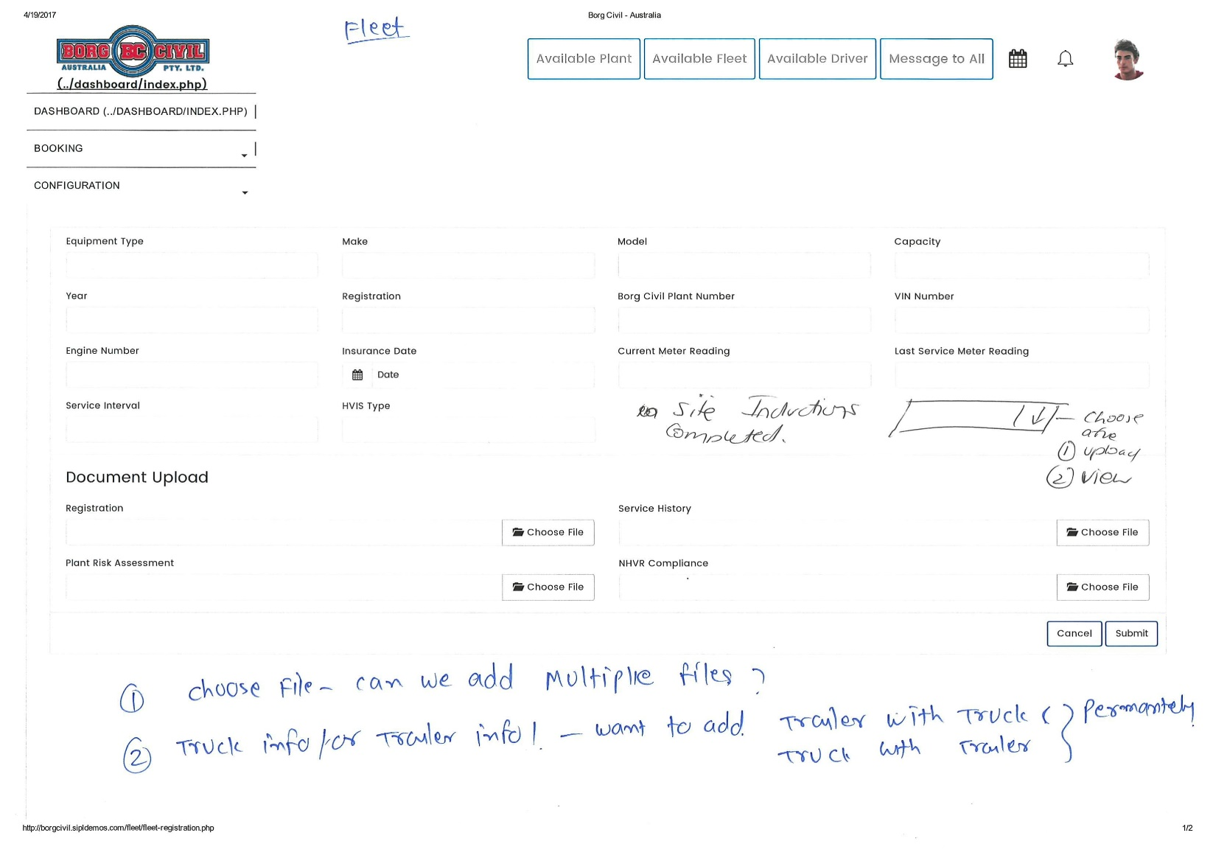

SIPL Understanding:

* We need to add multiple file uploader option named as “Site Inductions Computed”. Admin can view and upload documents/ images/ PDF in it.
* We will also add multiple file uploader for – Registration, Service History, Plant Risk Assessment & NHVR Compliance.

SIPL Queries:

* Can you please put some more light on – “Truck info for Trailer info – want to add (Trailer with Truck & Truck with Trailer) permanently” If Truck (ABC) having attach Fleet (EFG) all the time than at the time of booking if we select the truck(ABC) than trailer (EFG) automatically comes out with the truck with ability to change of the trailer.
* What will be the impact and flow of above change in booking? There will be no change in the flow or booking
* Will there be other combination as well for fleets? - Except Trucks there will no other combinations.

# Driver Registration

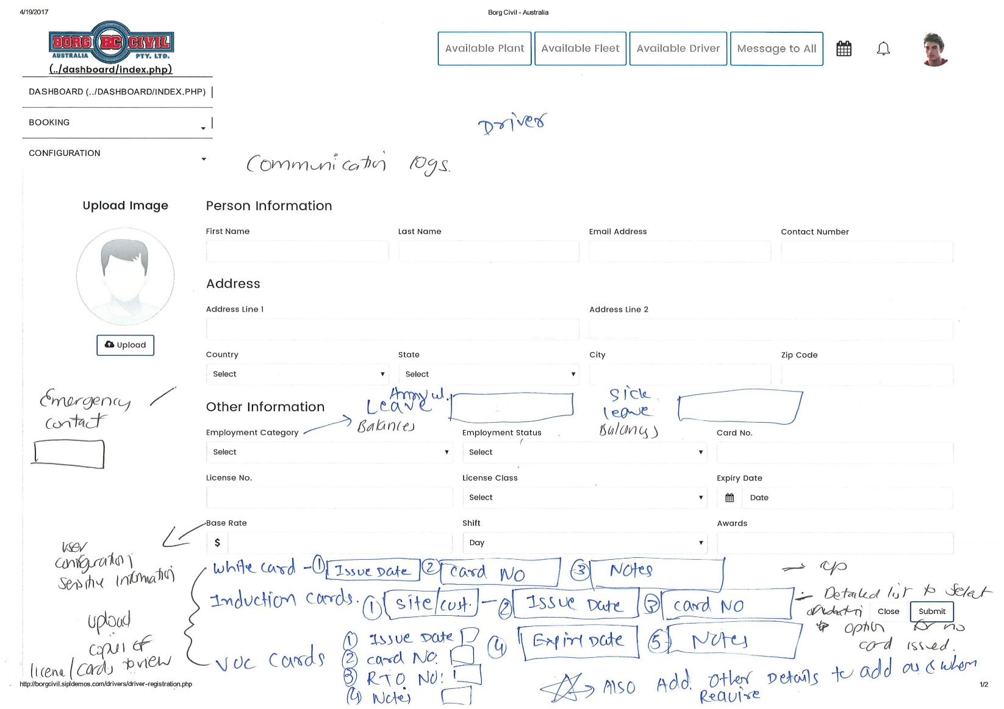

SIPL Understanding:

* For driver registration, below new fields will be added in main sections:
  + Personal Information:
    - Emergency Contact Name and Number
  + User Configuration Sensitive Information
    - Base rate
    - Shift
    - Awards
  + Upload Copies of License/ Cards
    - White Cards
      * Issue Date
      * Card Number
      * Notes
    - Induction Cards (Multiple)
      * Site/ Cost
      * Issue Date
      * Card Number
      * Expiry Date
      * Notes
    - VOC Cards (Multiple)
      * Issue Date
      * Card Number
      * RTO Number
      * Notes
    - Anonymous Fields (Multiple)
      * Title
      * Date Picker
      * Text Field
      * Text Field
      * Notes Field
      * Date Picker

SIPL Queries:

* Communication Logs: Which logs we need to keep in this? Currently we are not communicating anything to driver from system. - We can manually add any communications (e.g. any accidents happen and conversation with drivers and also upload the documents & Photos for incident reports)
* Annual Leave Balance & Sick Leave Balance
  + Do you want only the fields in which you only want to enter number of leaves available at the time of registration? Yes and time to time update manually
  + If any driver takes leave in future then manually admin will update these numbers.-Yes
  + Will annual leave and sick leave balance be different? Or Sick leave is part of annual leave.-both are different
  + What will be the use of this feature in our application?- It can help across the board what was happen with the driver as well as what type of leave balance available to be handy to management.